St Lucia Escalation Tickets

This manual serves as a guide for all escalations to Tier 1 teams in St Lucia

At login all agents will see a new Start Center labeled **CCFTCCSLU**

1. Click on this tab



The **Quick Insert** Menu lists all the different escalations that can be reported by an Agent

|  |  |
| --- | --- |
| **Quick Insert** | **Group** |
| Data Issue | Contact Center |
| Video Issue | Contact Center |
| Voice Issue | Contact Center |
| Add/Remove Internet | Customer Care |
| Add/Remove Voice | Customer Care |
| Add/Remove Video | Customer Care |
| Address Upload | Application Support |

1. Click on anyone of these options that is related to your call and needs to be escalated

In this example we will use “Data Issue”

The classification was pre-populated as well as the assigned group



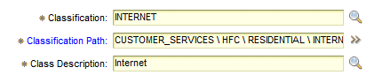

1. **Reported By**: your username then press **TAB**
2. **Source of Ticket**: PHONECALL
3. Clear the Customer information in the **Customer/Name** field
4. Search for Customer information

* Press the **>>** next to the **Customer** field
* Press **Select Value**



* Enter the customer account number in the Customer Charge Account field then press ENTER

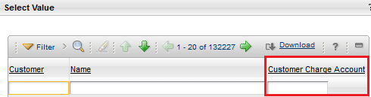

* If the Customer account number does not exist, we need to create the account
  + Press **Cancel**
  + Press the **>>** next to the **Customer** field
  + Go To 🡪 **Customers (CC)**

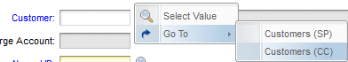

* + Select the new icon 
  + **Customer field:** first initial and last name e.g. LLAI
  + **Customer Charge Account:** Customer Account Number
  + Change the status of the customer to **ACTIVE** by pressing the  icon
  + Select the **Contacts** Tab



* + Click on **New Row**
  + Press the **>>** next to the Contacts field
  + Go To 🡪 **People (CC)**

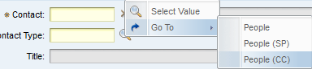

* + Select the new icon 
  + **Person**: first initial and last name
  + Enter all the information that is available for the customer
  + Press the Save icon 
  + On the top right hand corner of your screen, select **Return with Value**



* + Press the magnifying glass next to the **Customer Contact Type**



* + Select **ADMIN PRIMARY**

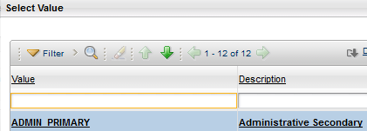

* + Press the Save icon  for the Customer
  + On the top right hand corner of your screen, select **Return with Value**



1. Press the magnifying glass next to the Customer Name field and select the contact



1. **Summary** field: Account Number – Issue
2. Include the following in the **Customer Summary** field
   1. Name of Customer
   2. Services
   3. Pole Number
   4. Node
   5. Issue
3. Change the Site to **CCSLU**



1. Press the Save icon 

To create another ticket, press **Start Center**